**Day 2 - Monitoring Tool -Prometheus & Grafana**

* Prometheus is a monitoring tool.
* So, Prometheus and Grafana are 2 different tools. But we'll be integrating both the tools.
* So, using Prometheus, you do all the monitoring part, you get the reports. We get all the information from our infrastructure and the application.
* we use Grafana just to visualize the reports that we got from the Prometheus.
* So, you have a lot of information. You will get lot of information from the infrastructure or from your application. You get a lot of information generates it keeps generating lot of reports. So just by looking into the report, getting some insights like getting some proper data will be tedious. We use a tool called Grafana, which is a data visualizing tool. So Grafana is a visualizing tool that we integrated with Prometheus.
* your data can be visualized so that it will be easier for the person who's looking into the data.
* So, it will be easier when something is given to you in the form of pictures rather than putting them in a 1 long document.
* If some data is given to you in the form of images, you can easily understand. That is what we are doing it here. Instead of giving the report in the form of document, we are giving it in the form of visuals. So, we'll be integrating a tool called Grafana, so that this Grafana will help you to visualize your data.
* using the data scraping mechanism, your prometheus will collect the metrics from your infrastructure.
* Prometheus uses a full based model, which means it periodically pulls the metric from the configured machine or the configured endpoints. So if I have a Ec2, and I want to monitor that Ec2.So what I can do I can configure my Prometheus in such a way that it monitors, it collects the data periodically from my Ec2.
* here your Prometheus, they have a database. If you see here, here you have this Prometheus server inside your Prometheus server. You have something called as Tsdb, just nothing but Time series database where your Prometheus stores all your collected data, your scraped data. Everything will be stored in the time series.
* here the data will be properly organized in your Tsdb. That is your time series database. Your data will be organized with the name of metric and label.
* so that if you want to query this database, okay, if I want to fetch any particular data, says, Suppose I am like. I am retrieving some logs. Your Prometheus is collecting some logs. I don't want all the logs that is being generated. I only want the error logs. So what we do, we all the logs will be there will be stored in my time series database.
* So your Prometheus will use a language called is prompt Ql to query the database**.**

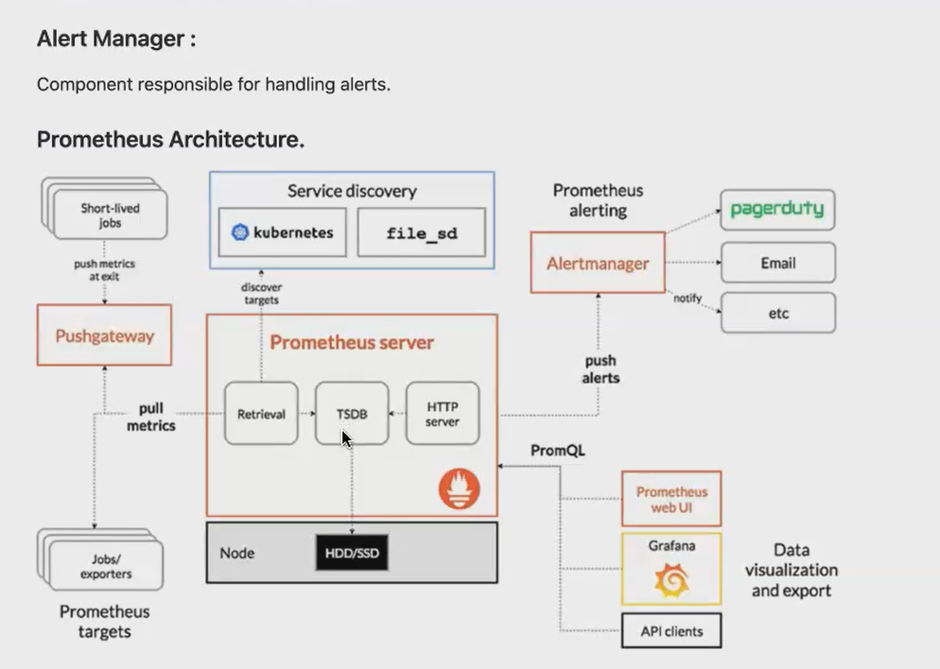

**Document:**

[**https://docs.google.com/document/d/1_GDbffYmO7_45fkbd8Kv5msckANjftaM0JpbweAvQF4/edit**](https://docs.google.com/document/d/1_GDbffYmO7_45fkbd8Kv5msckANjftaM0JpbweAvQF4/edit)

[**https://docs.google.com/document/d/1ELfM7oR-p4N5J3qLxm7fEZS4RsTdYLnqSrKrjRz-NS4/edit#heading=h.llwfmcv7eivz**](https://docs.google.com/document/d/1ELfM7oR-p4N5J3qLxm7fEZS4RsTdYLnqSrKrjRz-NS4/edit#heading=h.llwfmcv7eivz)

**[ installation doc]**

[**https://docs.google.com/document/d/1Jc3g0VxRbTtotgmVMM3ct9v2--MrU1ypPqYE6JnlTK4/edit#heading=h.ic9fb6wlxlki**](https://docs.google.com/document/d/1Jc3g0VxRbTtotgmVMM3ct9v2--MrU1ypPqYE6JnlTK4/edit#heading=h.ic9fb6wlxlki)

[**https://github.com/yasminjeelani/Prometheus_Grafana**](https://github.com/yasminjeelani/Prometheus_Grafana)

1. **Launch an ec2 [ubuntu] and connect it.**
2. **Clone the above github repo. everything in this repo**

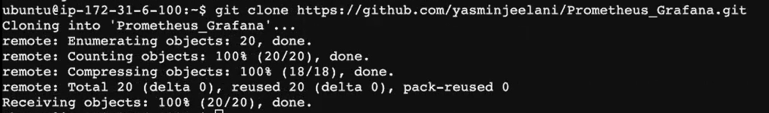



**Install-prometheus file: [its an UI] open port no: 9090**

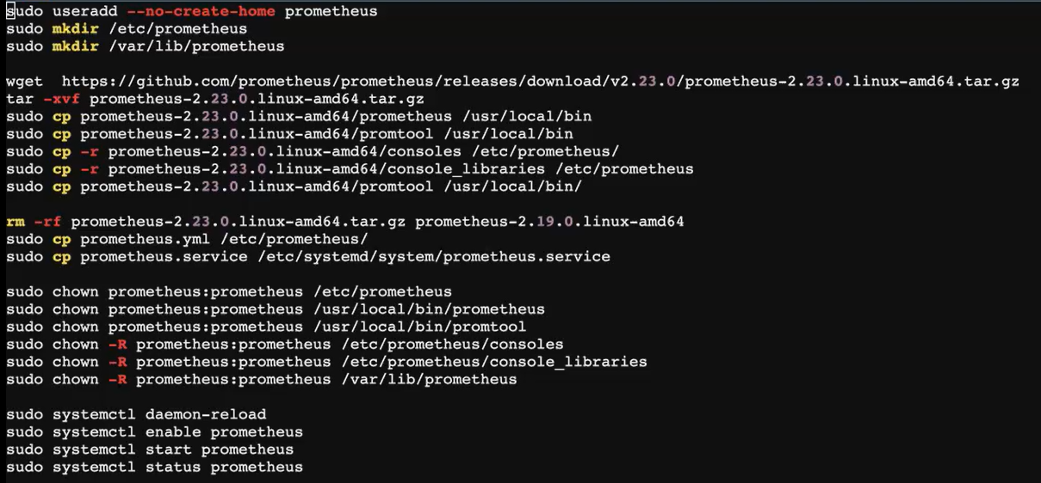



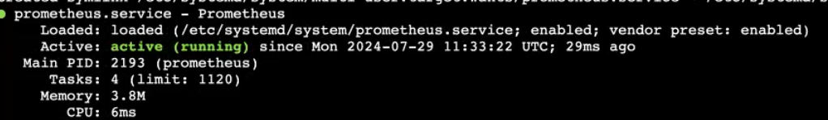

**After install Prometheus, /etc/Prometheus folder created.getinto this folder.**

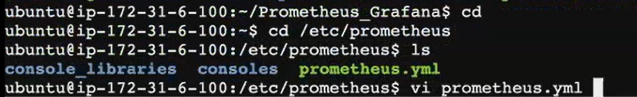

**Prometheus.yml [ configuring file]**

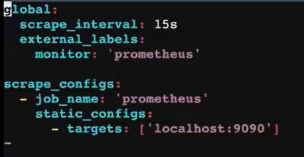

**Open the port no: 9090 [Prometheus port no:].copy ip address of the ec2 and paste it in browser. This is the Prometheus page.**

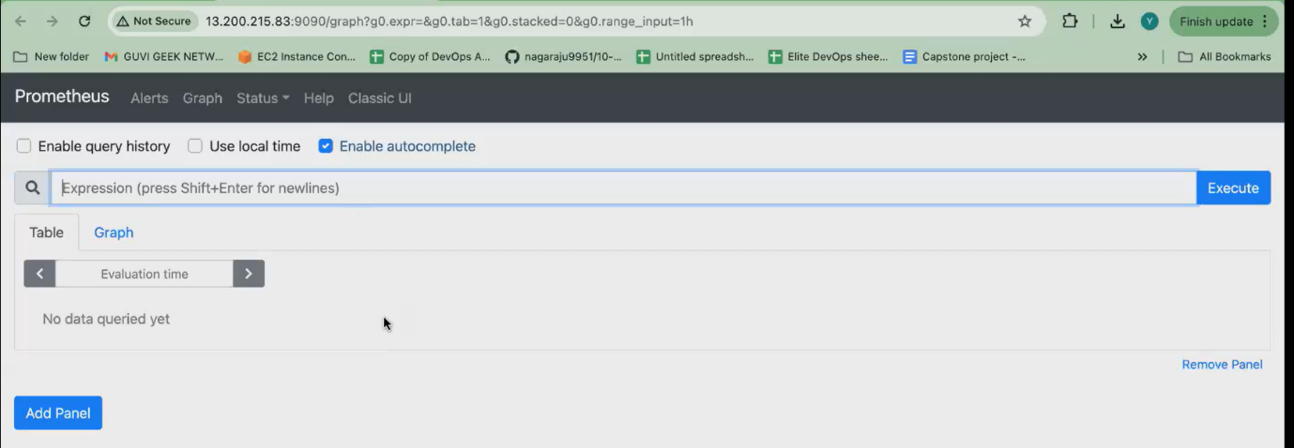

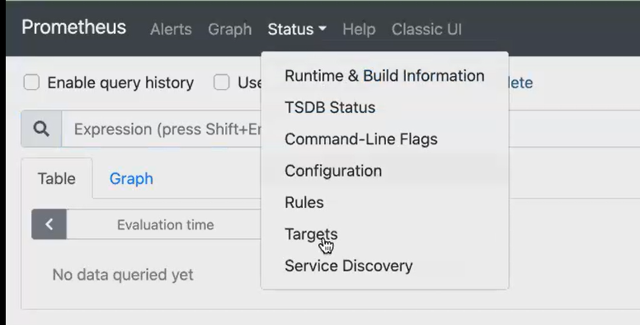

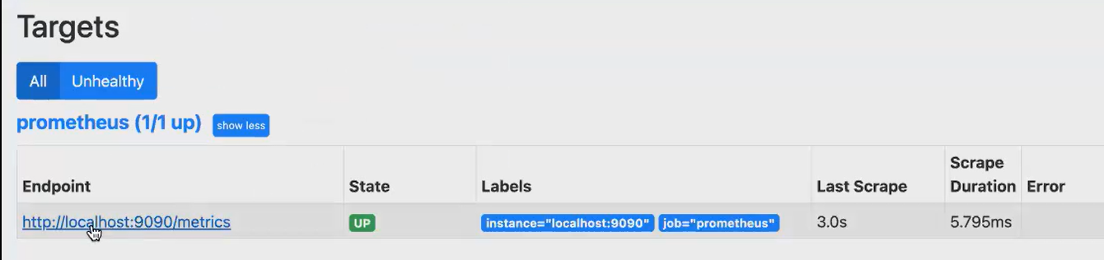

**Install node exporter: [its an UI]. open port no: 9100**

* **This node exporter will collect your data from the Ec. 2. So what is your Cp usage? What is your network usage? What is the disk? Usage, all the data your node exporter will collect and include it to your Prometheus.**

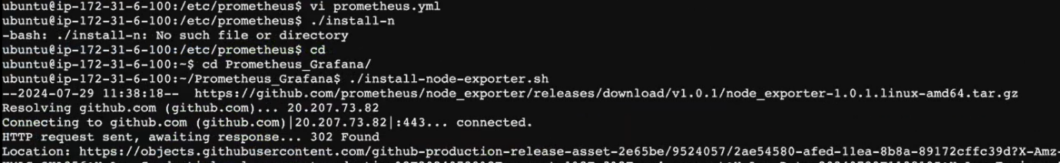

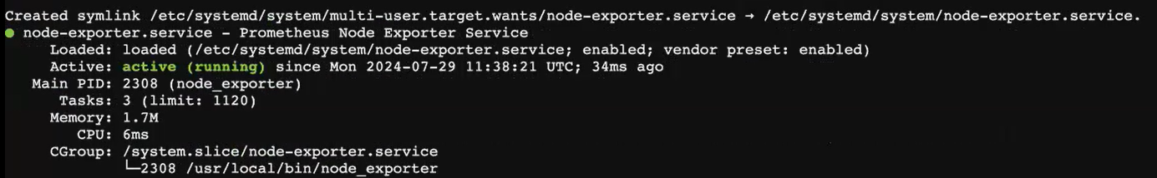

**open port no: 9100**

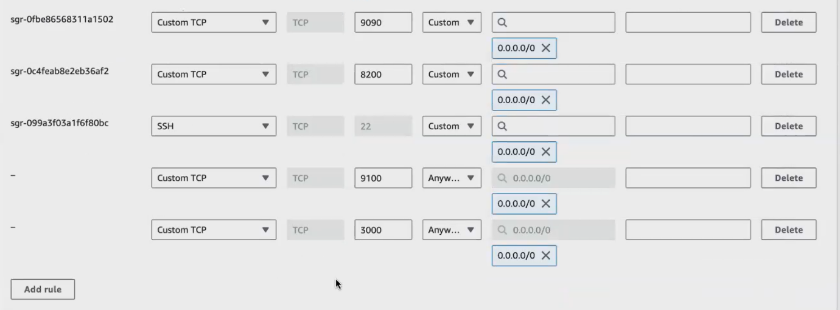

**Install Grafana: [its an UI] open port no:3000**

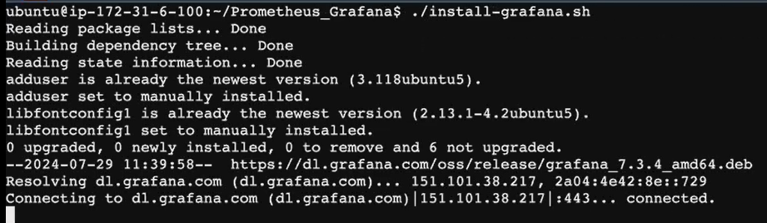

**Monitoring -server: [install Prometheus and Grafana]**

**Target -server: [install node exporter]**

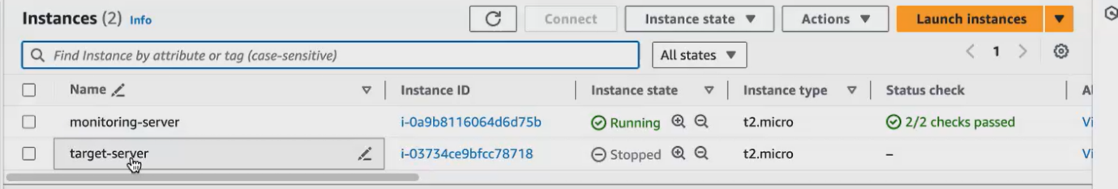

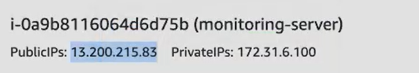

Copy IP address and open. This is login page .initially give username :admin password:admin.later on change it.

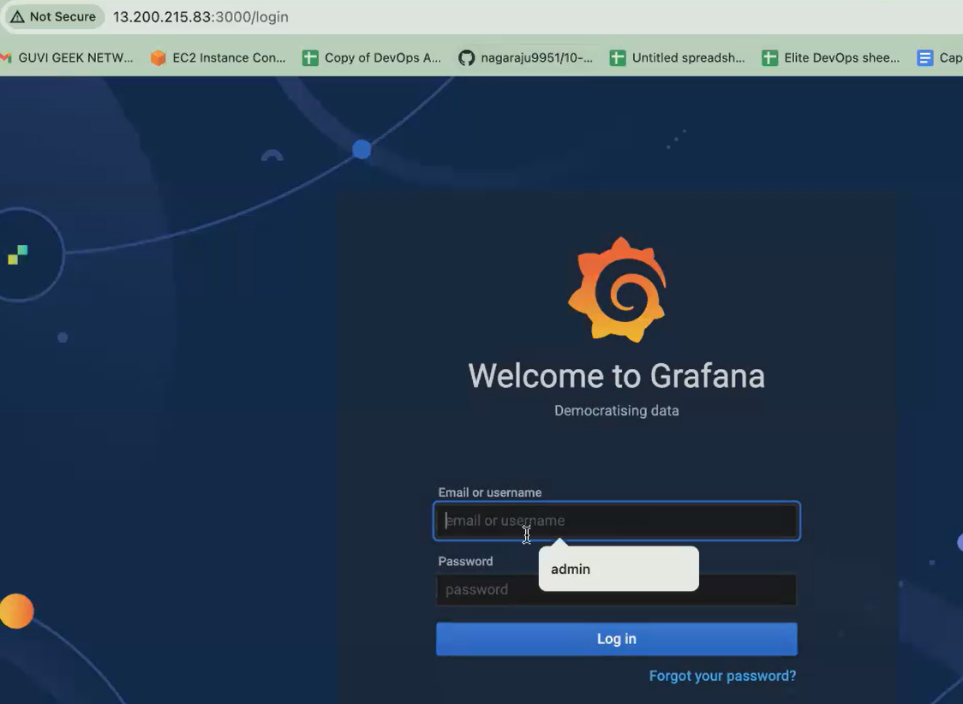

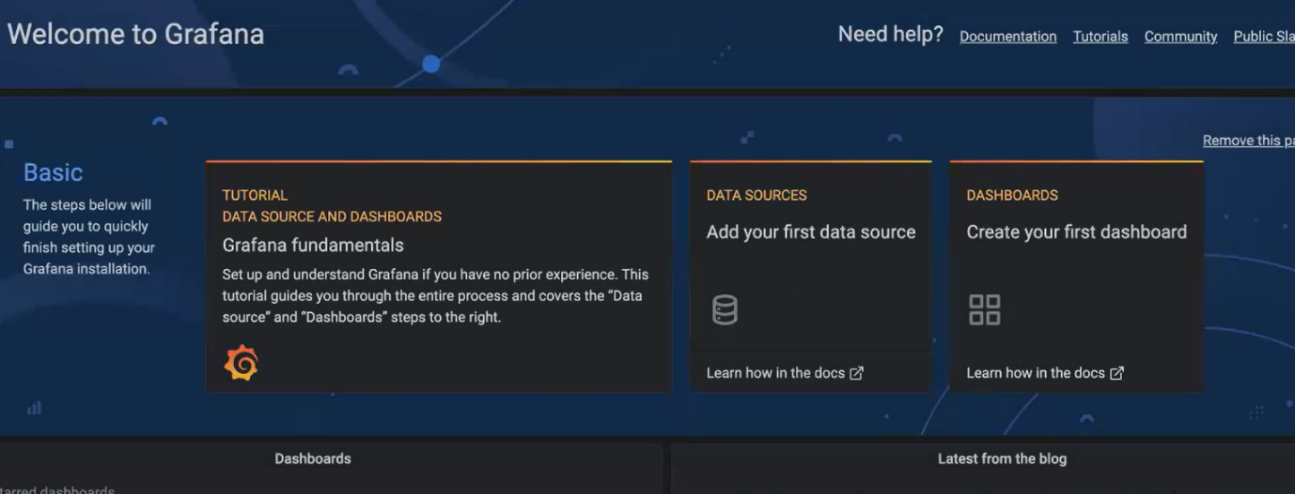

Copy monitoring server ip.This is node exporter page. Click metrics shows logs.

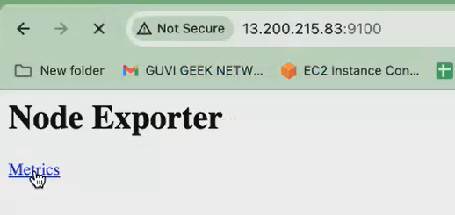



All installation script given in github

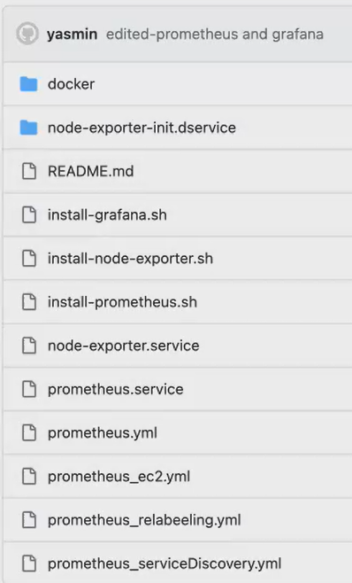

In target server install node exporter.

**This monitoring server have to monitor your target machine. Clone the repo in target server.**

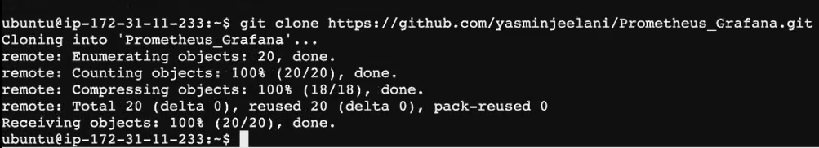

Once cloned. get into the Prometheus-Grafana folder. Execute the ./install-node.sh file

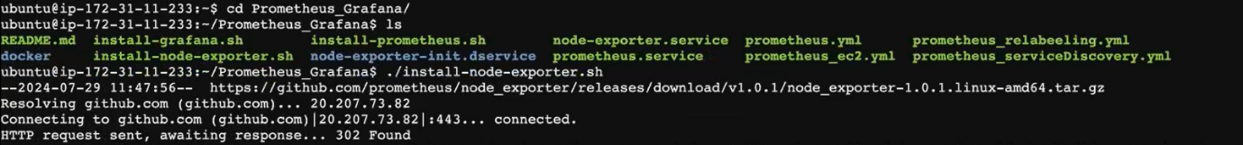

Get into monitoring machine. Edit the Prometheus.yml file , give sudo permission .then only edit this

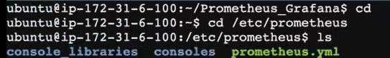

* Local host is node exporter. **So, who's collecting the data from the target machine. Your node exporter. So, Node exporter runs on the port number 9100.** **your local machine, the machine where I have installed my Prometheus.**
* Target -server ip address 43.204.233.40: 9100[ node exporter port no:]

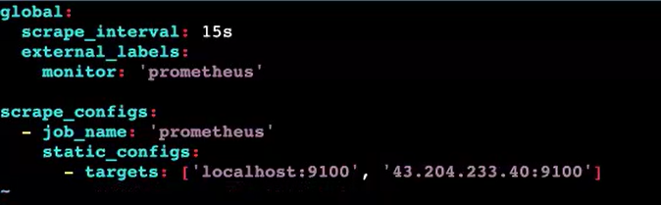

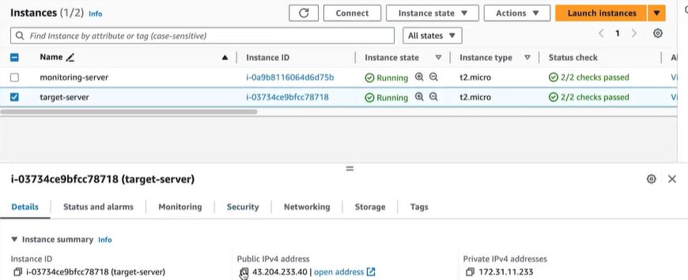

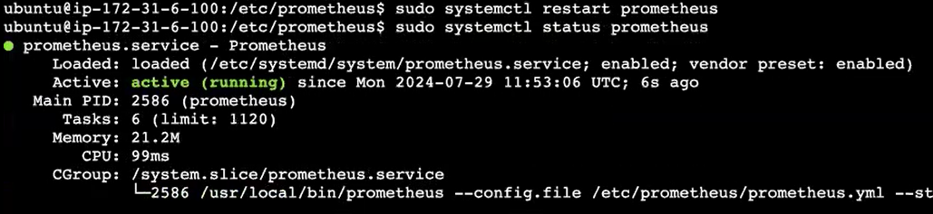

To restart your Prometheus, so give sudo systemctl **restart, because we are changing the configuration file. So for you, for you to apply the configuration. You have to restart it** now it's running. Now, my Prometheus is running.



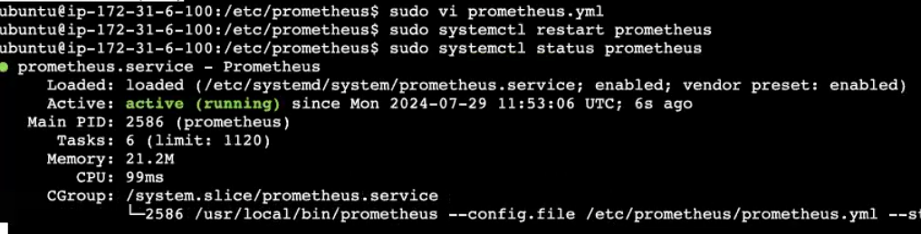

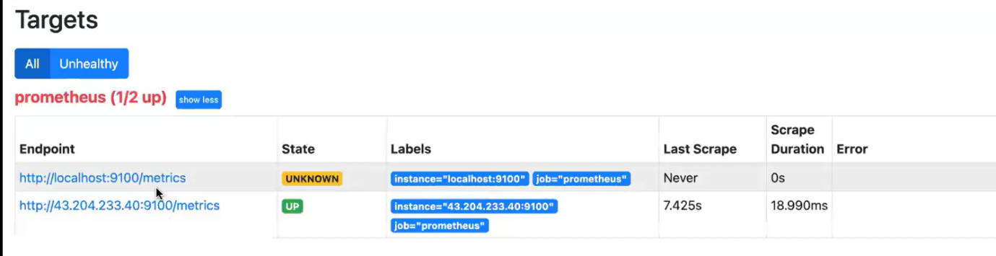

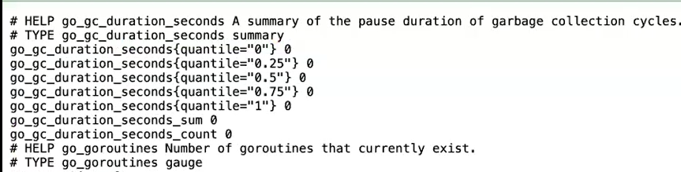

**integrating this Prometheus with Grafana:**

**Prometheus [ monitoring tool (i.e) monitoring the target machine)**

**Grafana [ visualization tool**]

* you can connect your Grafana with any data source.
* your data source can be a excel sheet or can be a Csv data source.
* And more mainly, we also use Grafana for data science projects also.
* To process the data to visualize the data we use Grafana.
* The Grafana is mainly a data visualization tool. The data source that we are using now is Prometheus. So Prometheus will get all the details from the target machine, so it will collect all the details from the target machine.
* Data base and data source is same.

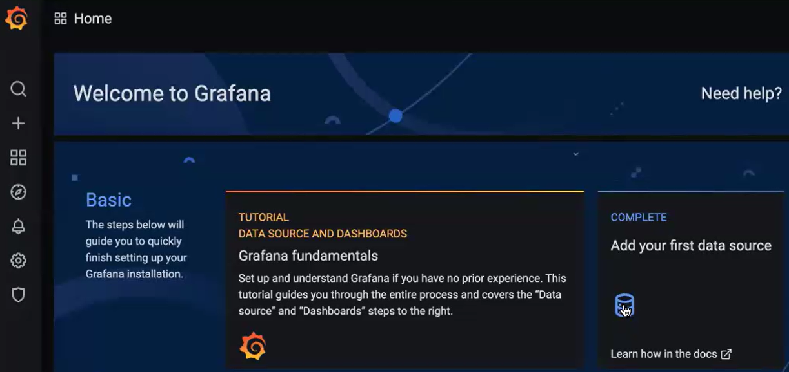

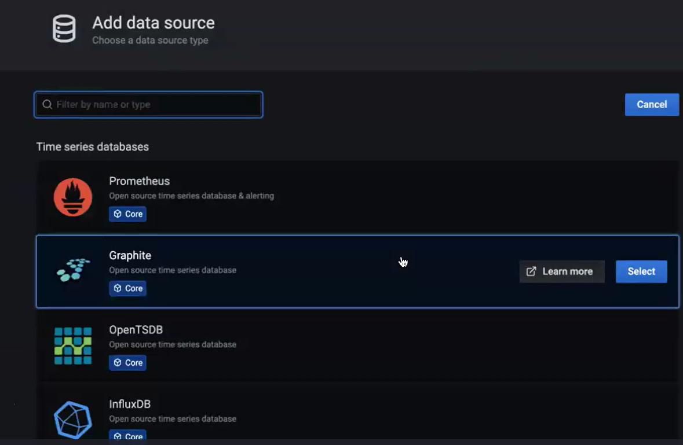

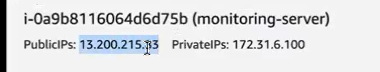

Copy the ip address of the monitoring machine. Because in this machine only install Grafana and Prometheus.

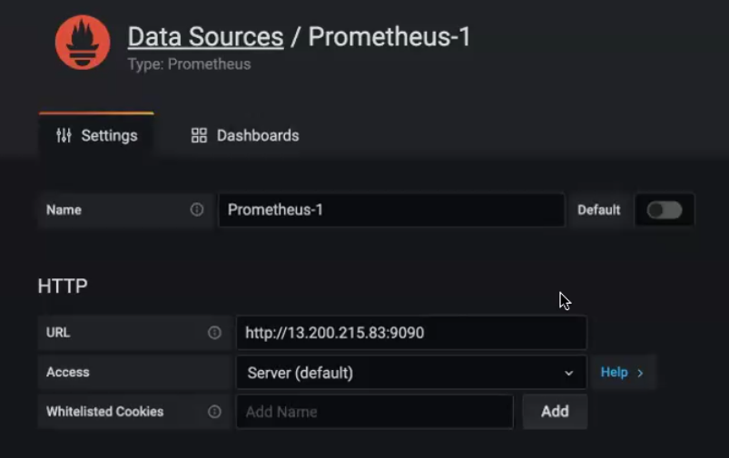



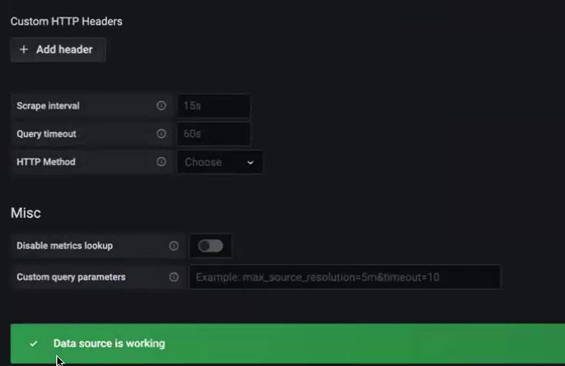

**Create a dashboard for CPU utilization:**

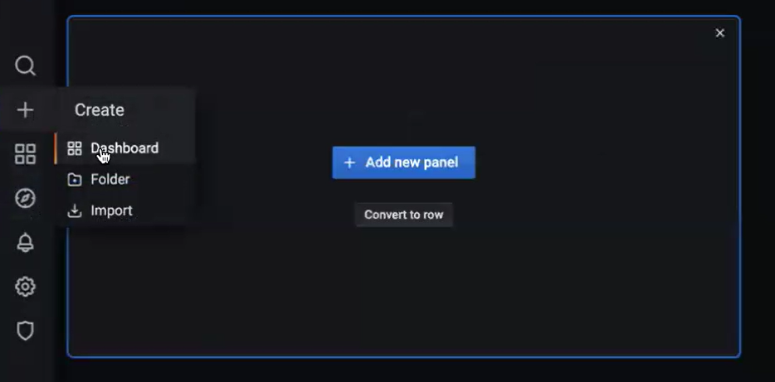

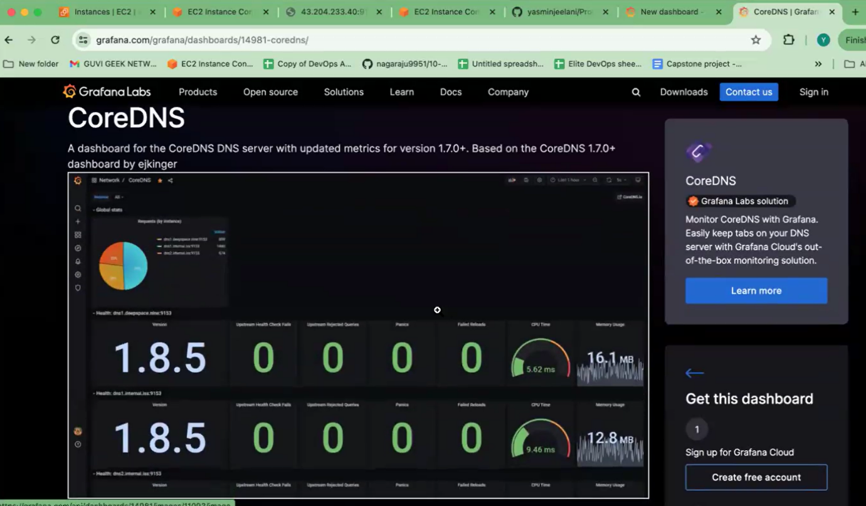

Node means system.Create metrics for CPU utilization 🡪 apply 🡪 select start

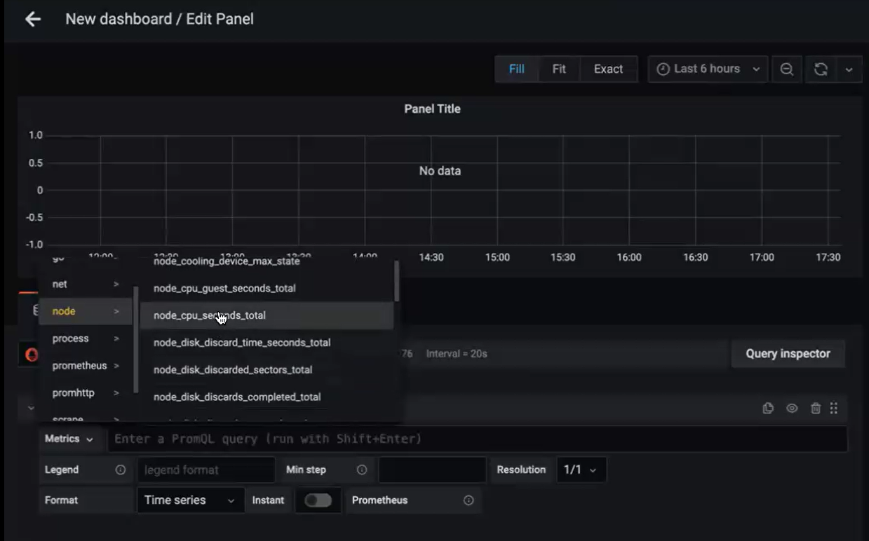

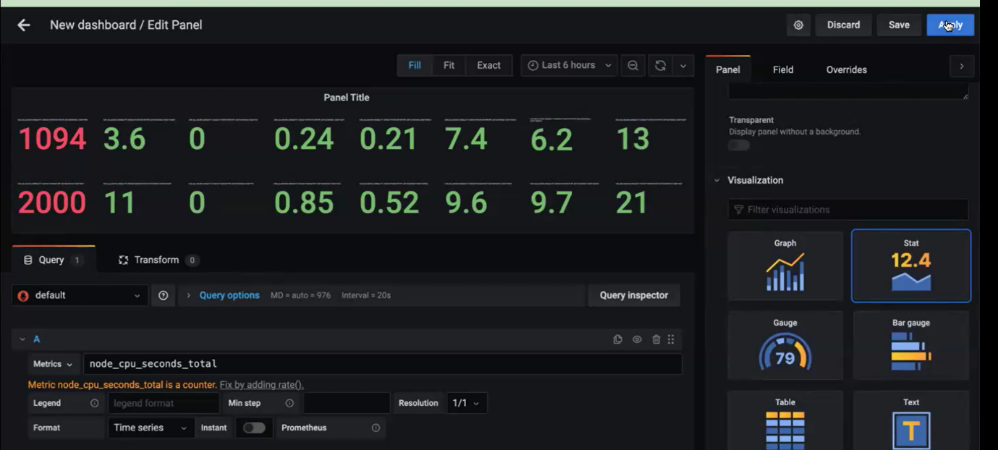



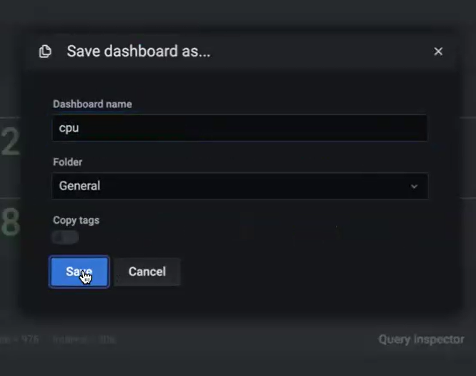

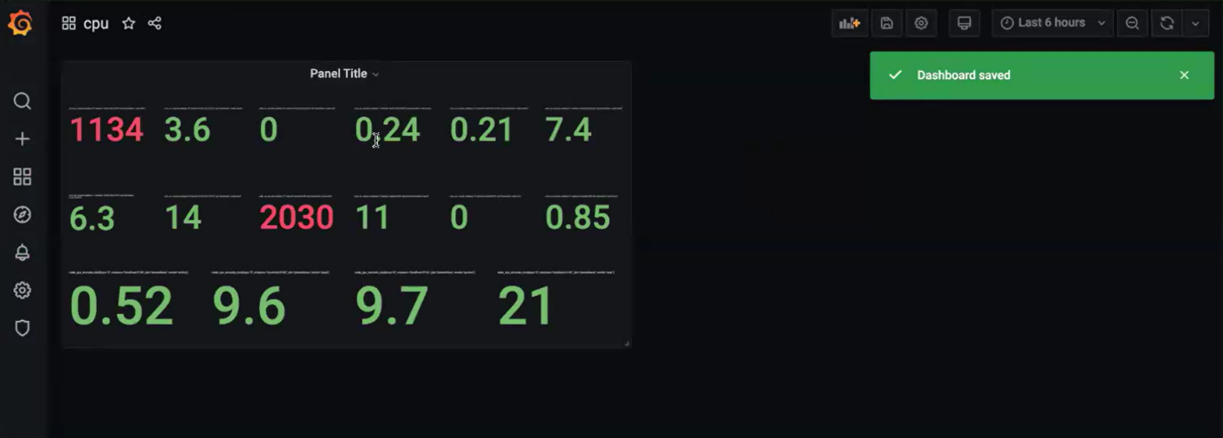

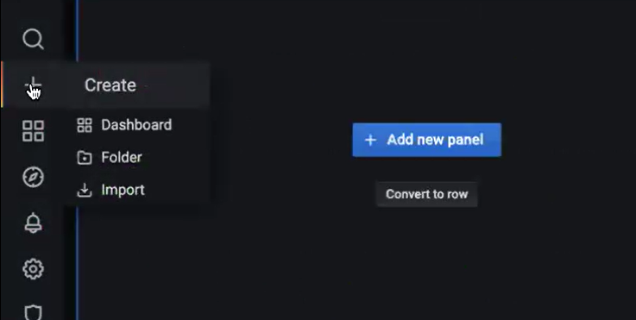

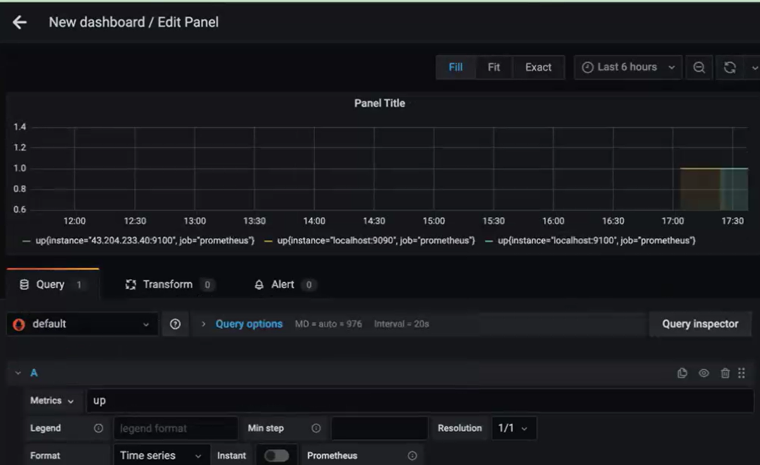

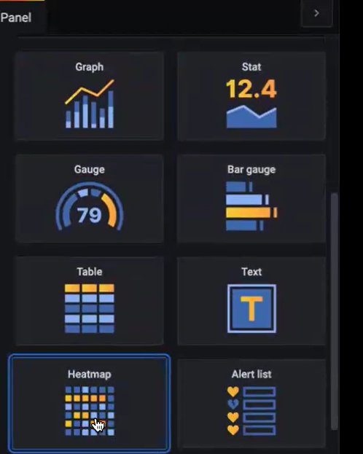

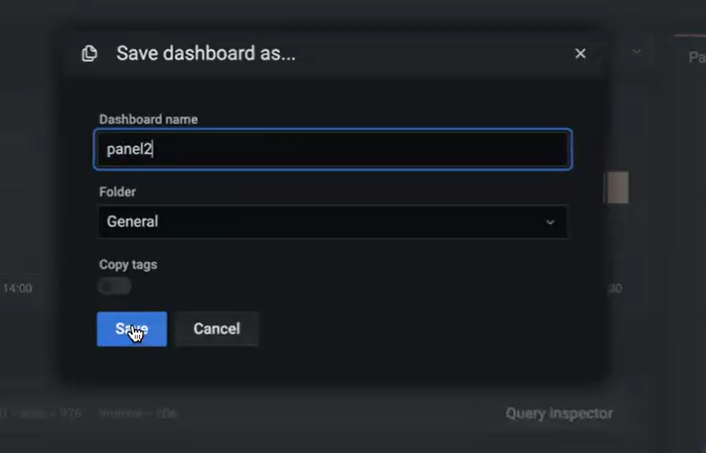

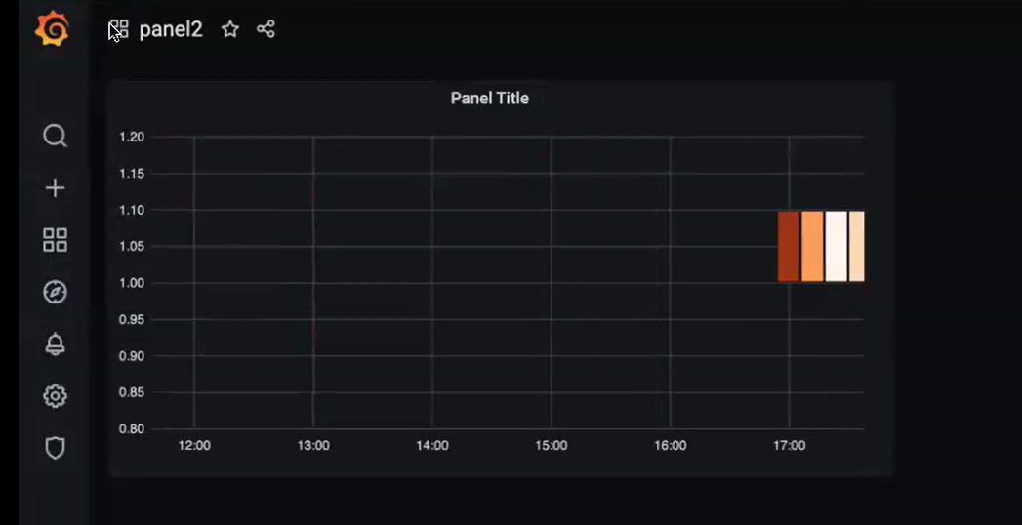

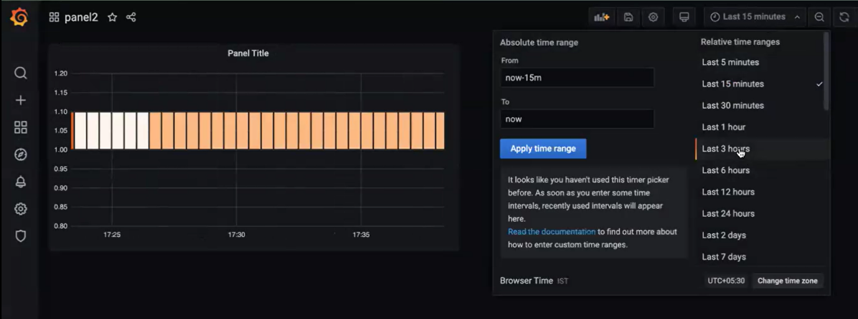

* Prometheus is mainly used to monitor your Kubernetes cluster only.
* You should have node exporter running. Without the node exporter you cannot collect the data.
* So in your target machine you will only have node exporter installed.
* But in your monitoring machine you will have all the 3 tools installed, and you should have configured the Security group also.

**we will see how to monitor, the Kubernetes cluster: [go through the below doc]**

**launch an instance and connect.**

**create Kubernetes cluster**

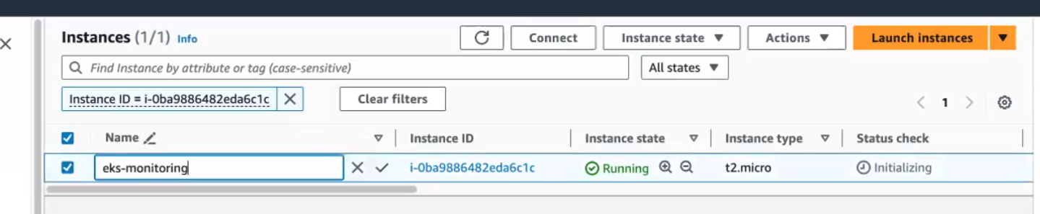



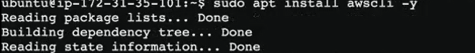

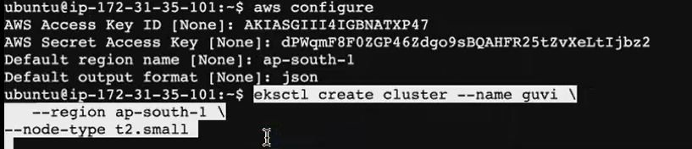



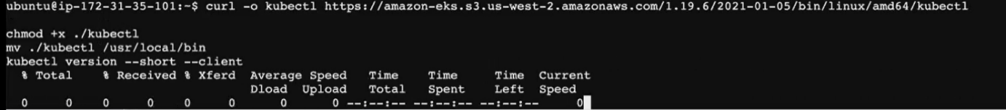



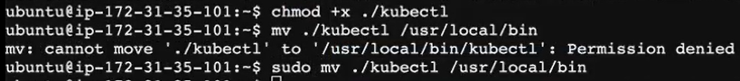





[**https://github.com/yasminjeelani/Prometheus_Grafana**](https://github.com/yasminjeelani/Prometheus_Grafana)

<https://docs.google.com/document/d/1_GDbffYmO7_45fkbd8Kv5msckANjftaM0JpbweAvQF4/edit>

<https://docs.google.com/document/d/1ELfM7oR-p4N5J3qLxm7fEZS4RsTdYLnqSrKrjRz-NS4/edit#heading=h.llwfmcv7eivz>

<https://docs.google.com/document/d/1Jc3g0VxRbTtotgmVMM3ct9v2--MrU1ypPqYE6JnlTK4/edit#heading=h.ic9fb6wlxlki> [**we will see how to monitor, the Kubernetes cluster ]**